**Meghana Rudra Raju**

**U05051020**

Business Analytics & Information Systems

**Final Project Report**

Most Dangerous Parks in New York City

Data Visualization

**Prof. Johannes Reichgelt, PhD**

**Introduction:**

Exploring the connection between urban parks and criminal behaviour in these settings captivates the attention of scholars and various governmental organizations engaged in environmental studies. This research endeavours to ascertain if a link exists between the substantial influx of visitors to New York's parks and the prevalence of illicit activities within the city. To delve deeper, our study concentrates on several pivotal research domains.

This line of inquiry must first determine whether or not there is a correlation between "the total amount of criminal activity that occurs in a certain region and the total number of parks that are found in a city." The "distribution of crimes in each borough based on their “Location of Occurrence" is the second problem that this research has to answer. This study must answer "Count of Location Occurrence per Date Based on Borough" as its third problem. "Map of Safe and Dangerous Parks" is the fourth issue that this research has to answer. The fifth problem that this study needs to address is "Total count based category”. The research must answer the sixth problem, which is the "Count of records per type based on Borough." The results of this investigation will determine the answer to this query. Not least among our tasks will be the creation of a dashboard.

The study aims to identify which of various parks in and around New York City is the safest by carefully examining the crime statistics related to each park in consideration. It aims to inform visitors about which parks are the most secure to visit while with kids. The concept aims to solve two major concerns for park visitors in New York City: safety and stillness. This method entails looking into the level of illegal activity taking place at various parks to make sure this objective is achieved.

To conduct our investigation, we will utilize the City Crime Statistics dataset, which has been made publicly available by the New York City Police Department and Data Society. This dataset provides valuable information concerning the occurrence of criminal incidents within the city. The data consists of official crime records, documenting the number of reported offenses in New York.

Upon collection and thorough examination, the study's data will yield significant insights into the interplay between New York City's parks and the incidence of violent and property crimes. These valuable findings will empower local government officials and policymakers to make well-informed choices regarding park management and security measures throughout the city. Furthermore, an in-depth analysis of the collected data will facilitate the development of recommendations for park visitors in New York City, pinpointing the safest parks for their recreational pursuits. Moreover, this comprehensive data analysis will uncover specific locations that may require additional safety measures if warranted.

The fundamental aim of this research project is to significantly improve public safety and security within the bounds of New York City, thereby making a notable contribution toward this objective. By unearthing insightful findings, this study will shed light on the complex interplay between urban parks and criminal activity, constituting a vital aspect of the research's purpose. Furthermore, these discoveries possess the capacity to influence public policy and community development decisions in New York City, particularly in areas pertaining to public safety and the nurturing of community progress.

**Methodology:**

The ongoing investigation relies on publicly available datasets provided by the New York City Police Department and the Data Society. These datasets serve as the primary source of information, offering comprehensive details on various crimes committed in New York City, including specific information on location, date, and type of crime.

Moreover, data regarding the quantity and precise whereabouts of parks in diverse regions will be incorporated. The study aims to investigate prevalent patterns of documented criminal behaviour across different areas and explore potential correlations between the presence of parks and occurrences of unlawful conduct. A comparative analysis will be conducted to examine crime rates within parks and other locations within the same community, seeking to discern whether specific types of criminal activities are more prone to transpire within the park or its immediate vicinity.

Through a thorough examination of the collected data, the research endeavours to identify noteworthy trends and patterns that may indicate the prevalence of specific illegal practices within park environments.

# **Analysis:**

My research questions are answered by performing below visualizations. Below visualizations serve as key tools in answering my research questions, providing meaningful insights into crime distribution, temporal patterns, and park safety within New York City.

**Q1. Analysis of Crime by Borough using Bar chart?**

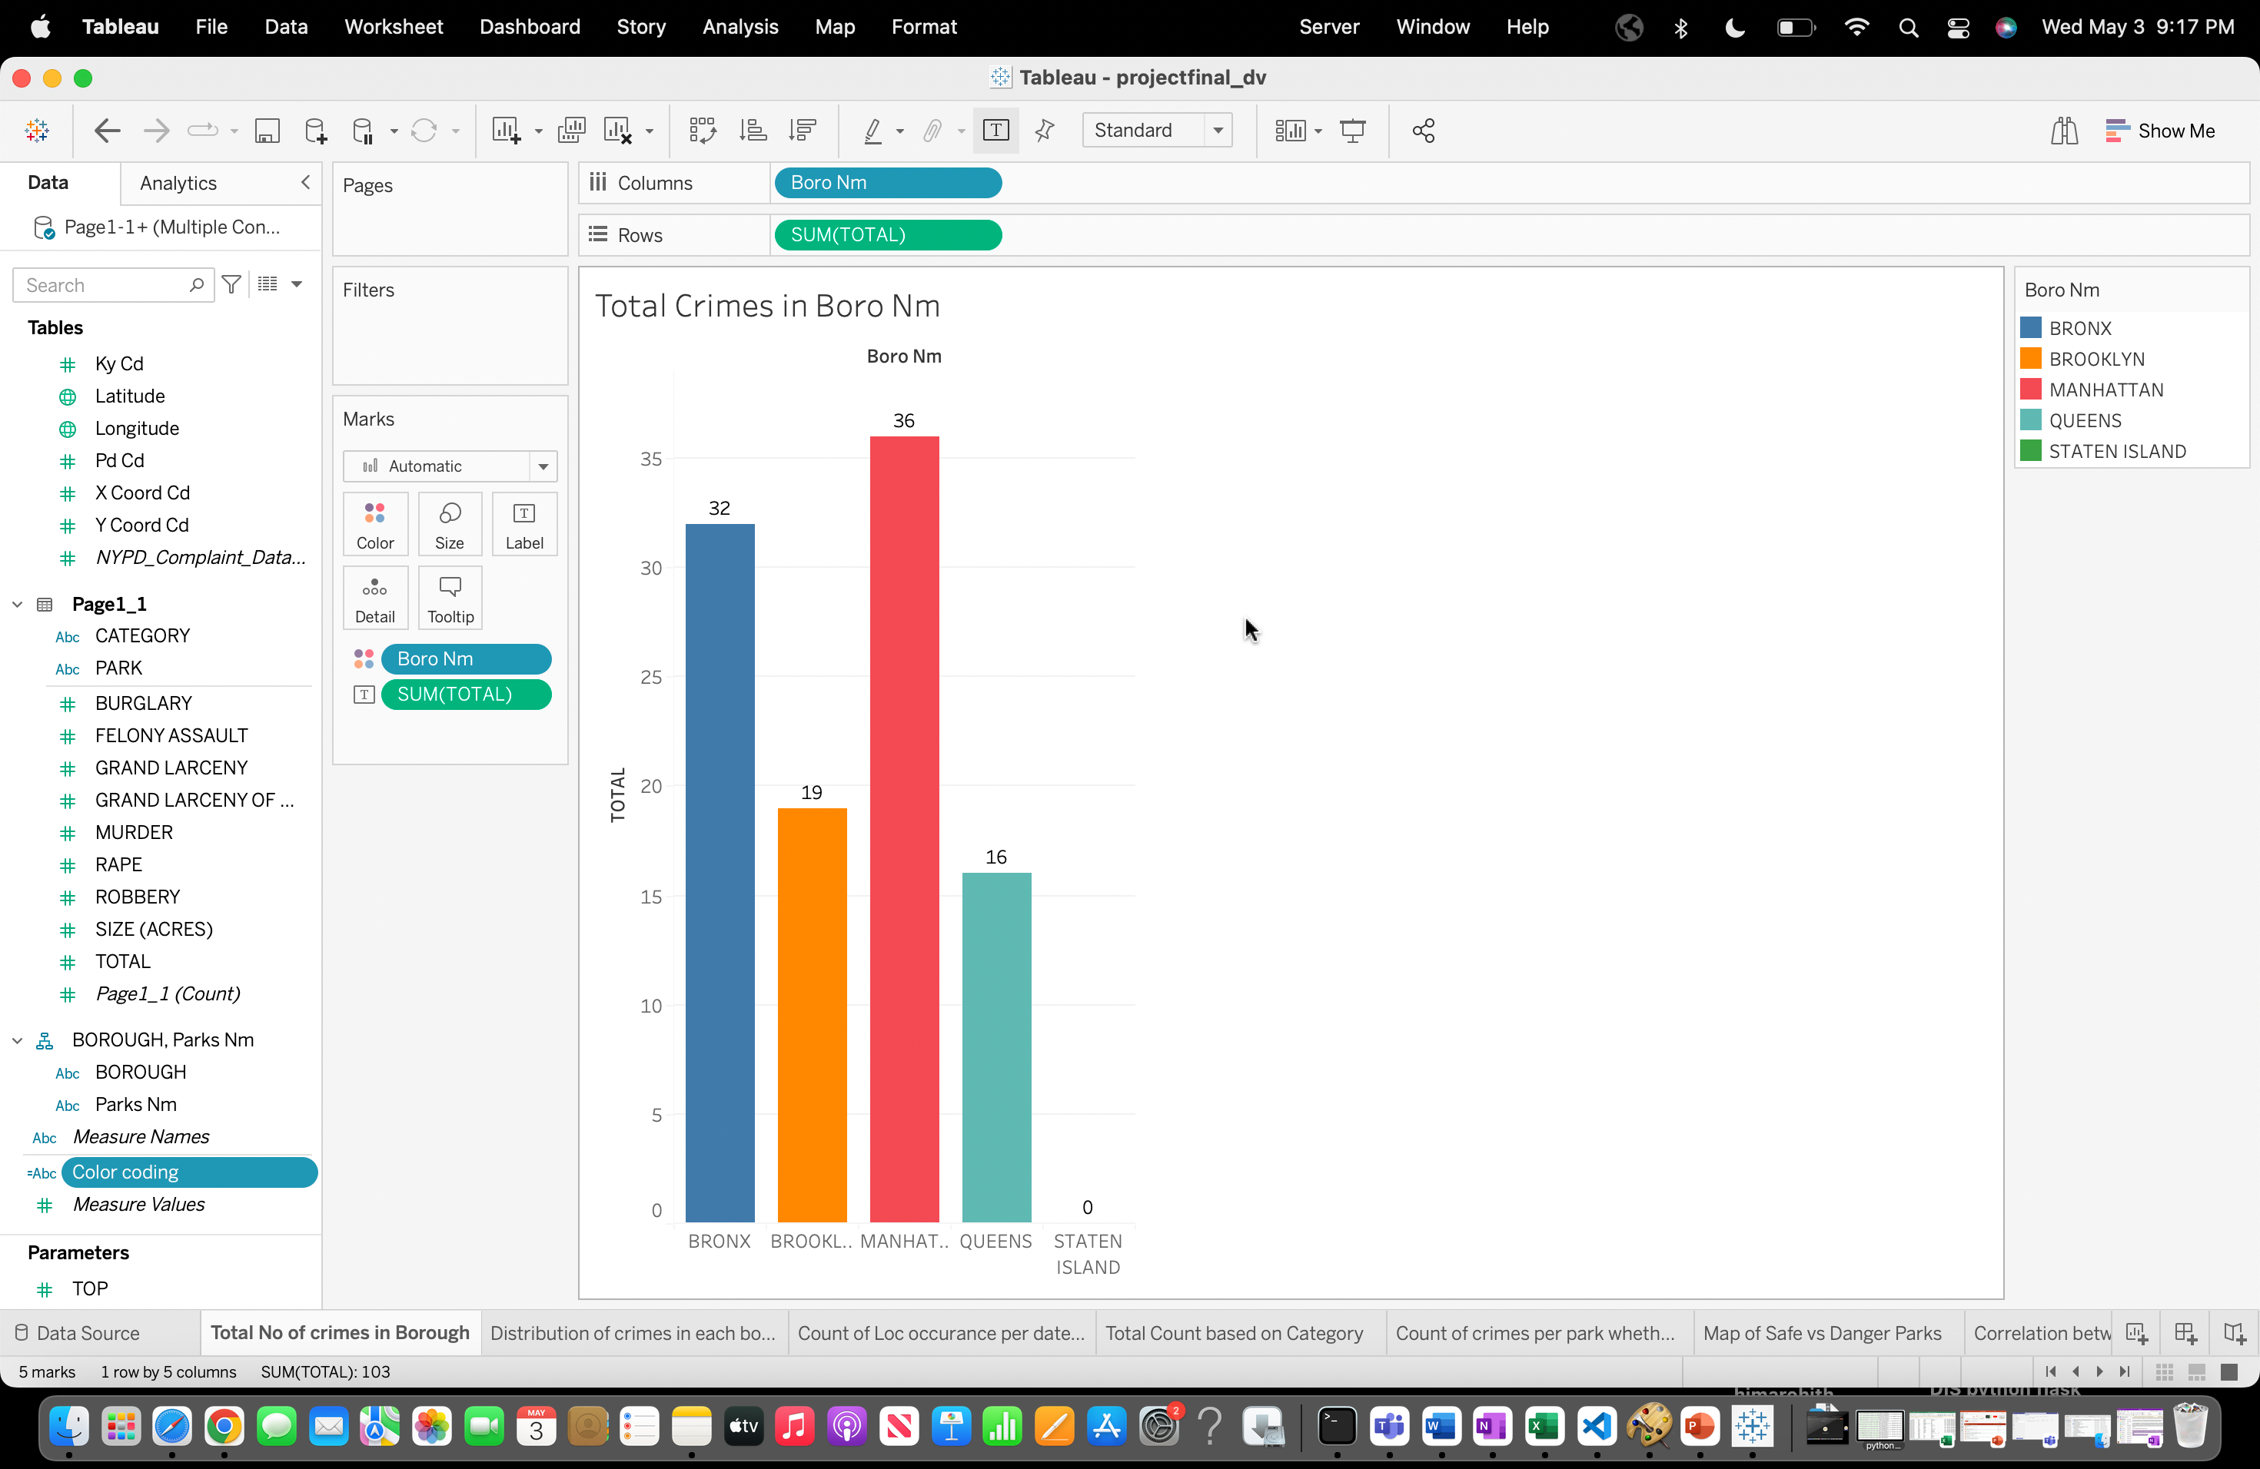

This visualization highlights the total number of crimes recorded in each borough, offering valuable insights into crime rates and patterns across different areas of the city. The data reveals that during Q1 of 2016, Manhattan experienced the highest crime rates, with a total count of 36 reported incidents. In contrast, Staten Island recorded no crimes during the same period, indicating a relatively lower crime rate in comparison. This information enables a comparative analysis of crime levels among the boroughs

**Q2. Crime distribution in each borough based on location of occurrence by using side-by-side bar chart?**

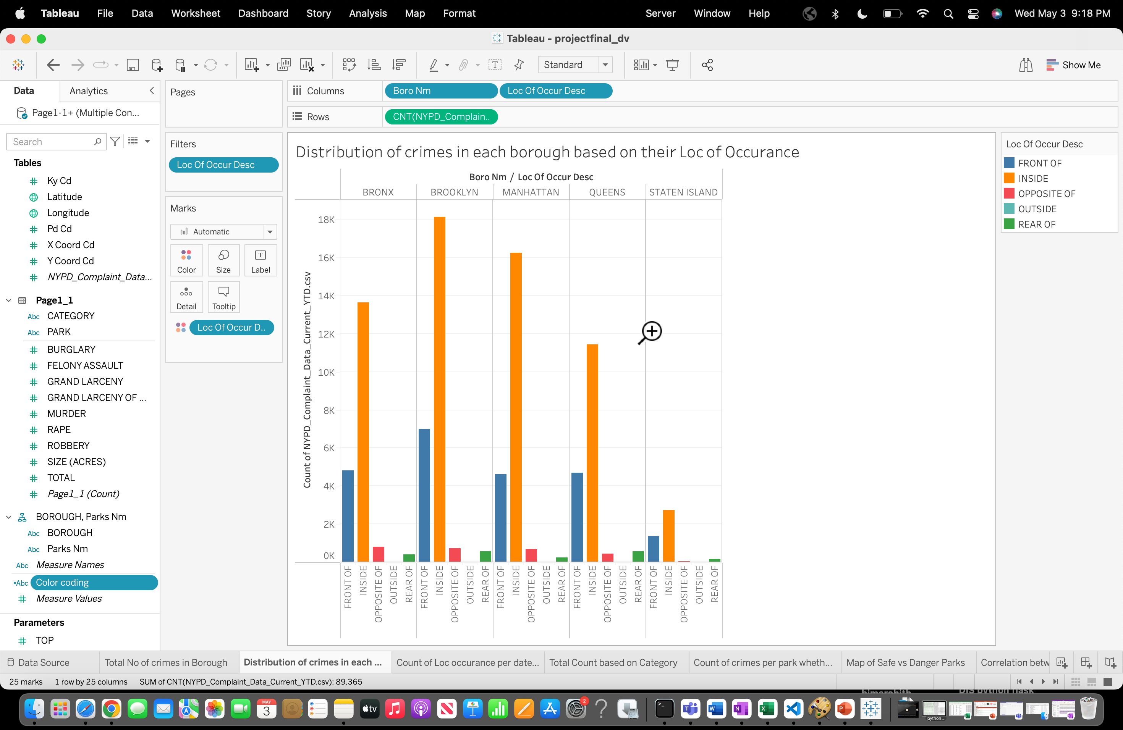

The visual shows the distribution of crimes in each borough based on their location of occurrence. “Brooklyn” is the most common location which has highest count compared to other ones,, while the “Staten Island” of laws is the least common one.

**Q3. Location occurrence count per date for each Borough using line graph?**

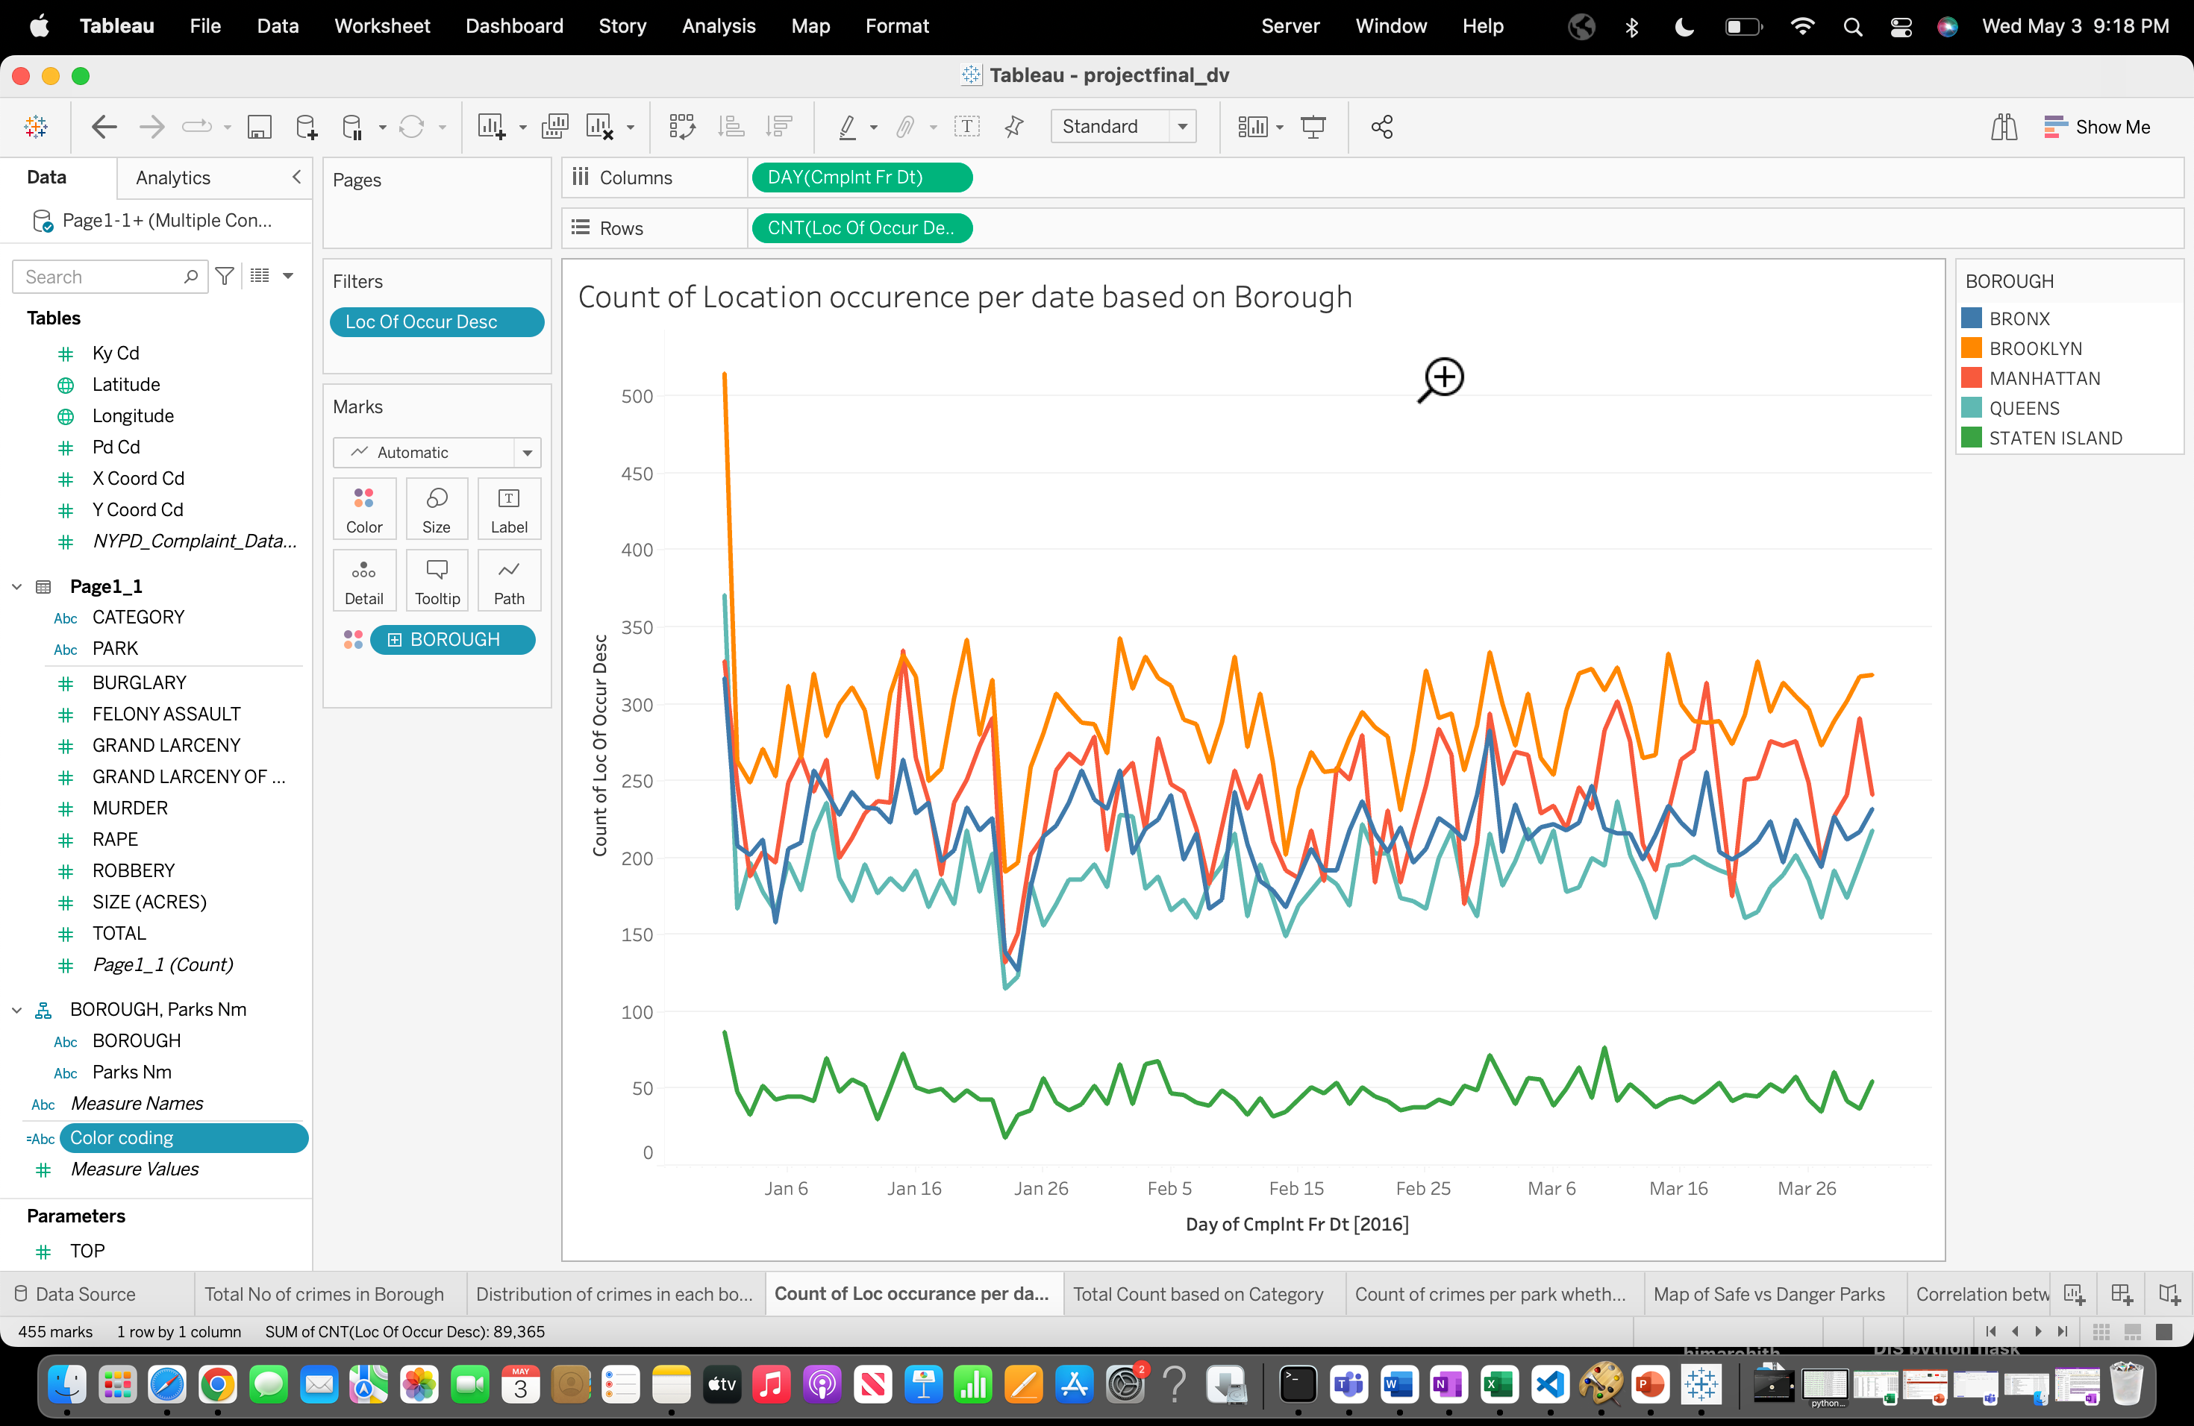

The graph depicts the number of occurrences  by date and borough. As we can see, the count was high on January 1st, 2016 for the Brooklyn site, while Staten Island had the lowest count compared to the other boroughs.

**Q4. Total count based on Category using bubble chart?**

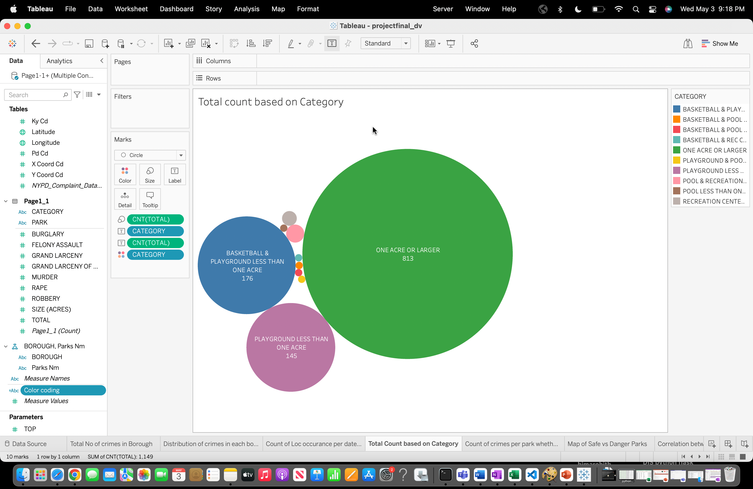

The visualizations depict the count values based on category, revealing that the "One acre or larger" category has a total count of 813, while the "Basketball and Playground less than one acre" category has a count of 176, both of which are higher compared to other categories.

**Q5. Count of data per kind based on borough, you can create a filter, parameter, and hierarchy using horizontal bar graph?**

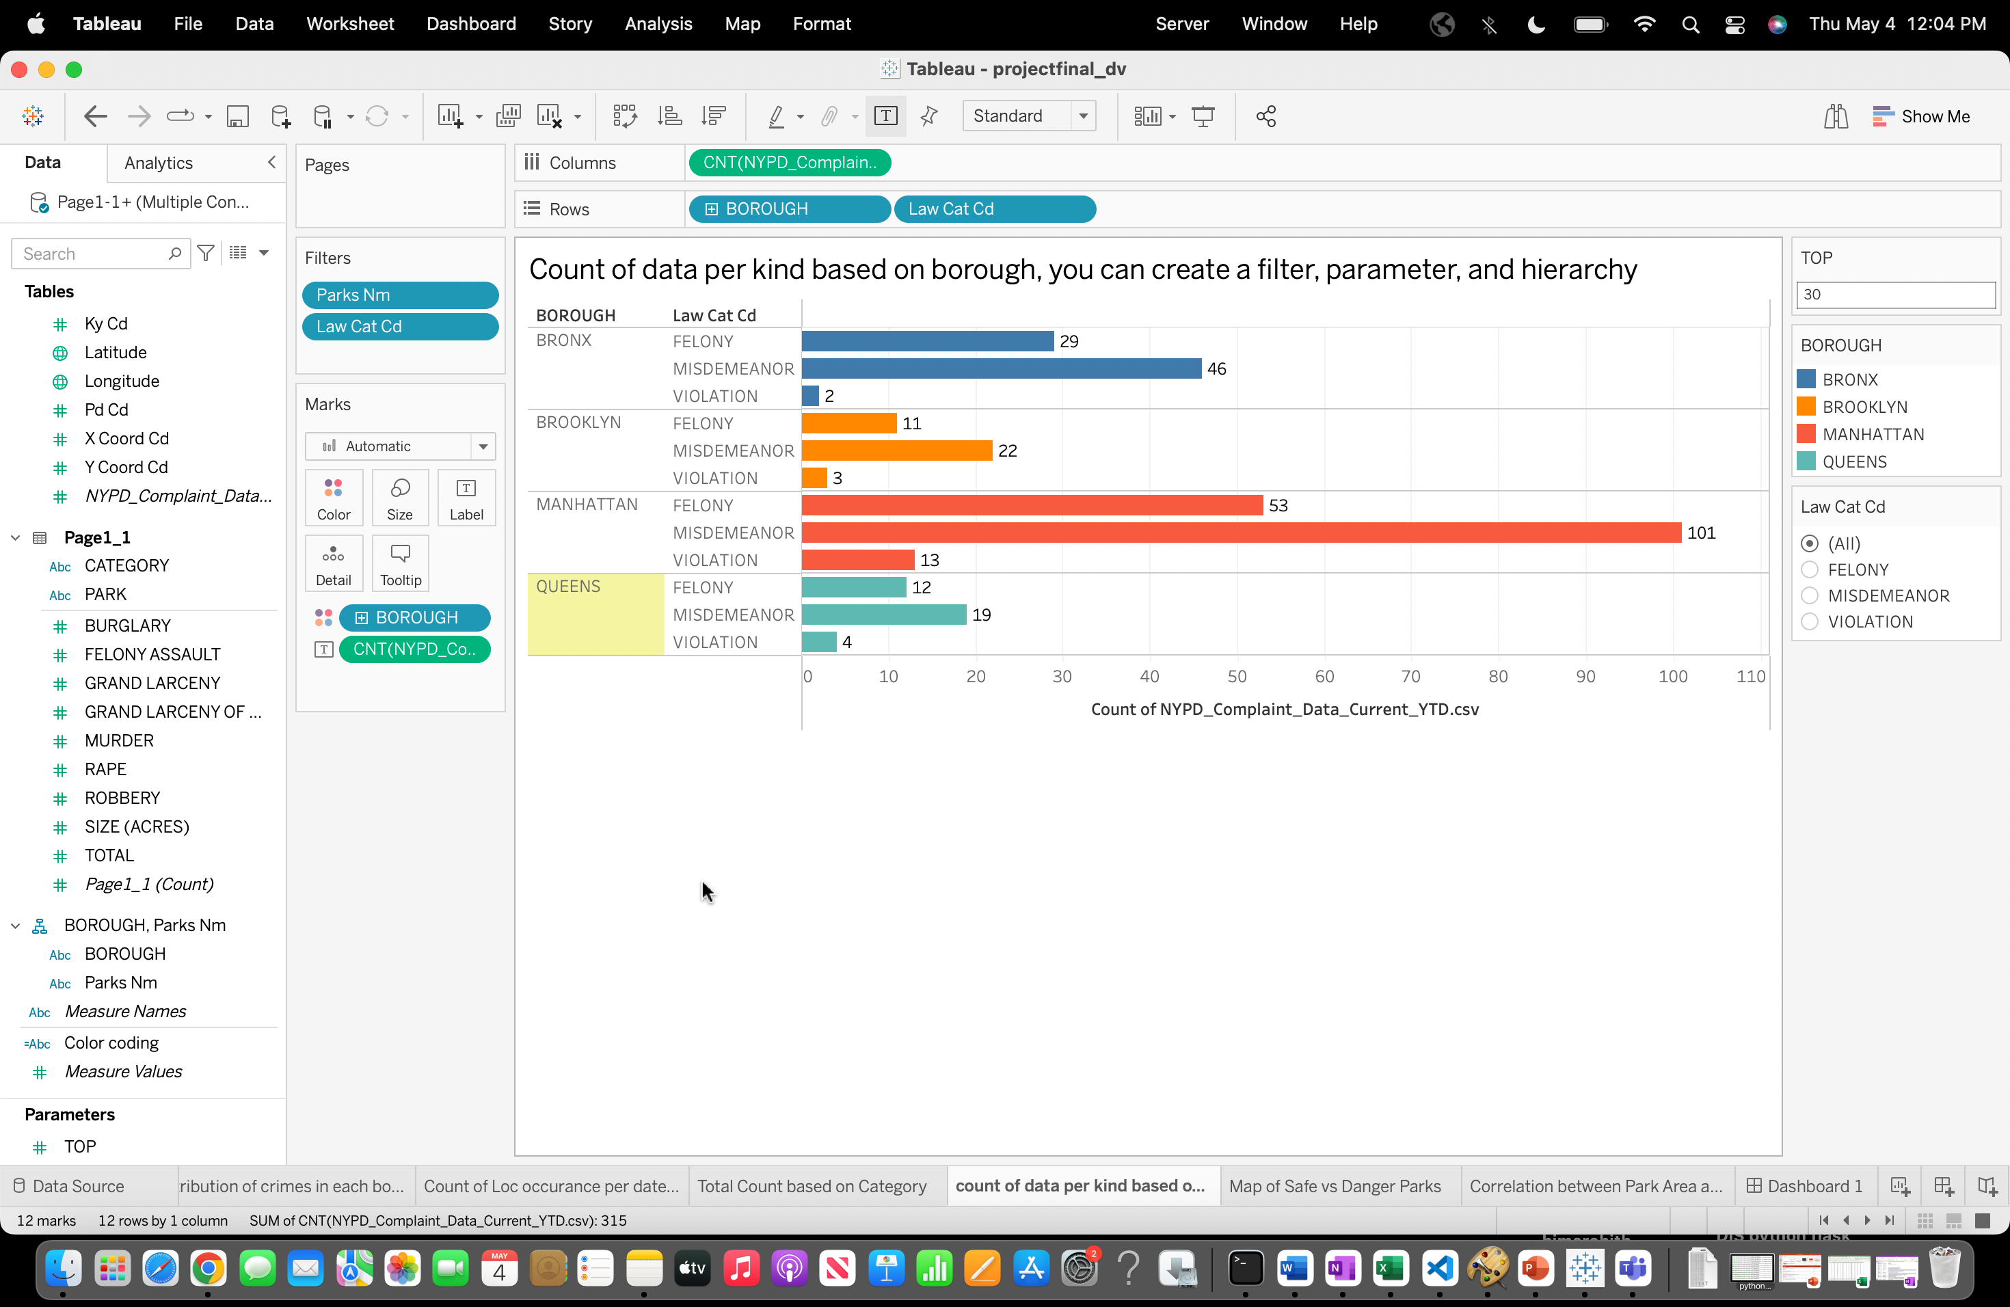

This analysis focuses on the count of records per type, categorized by borough. The hierarchy used includes Borough and Park Name, with an added filter for three levels of offense types. Additionally, a parameter called "TOP" is created to determine the top parks, which can be adjusted based on the parameter value.

**Q6. Map of Safe Vs Danger parks?**

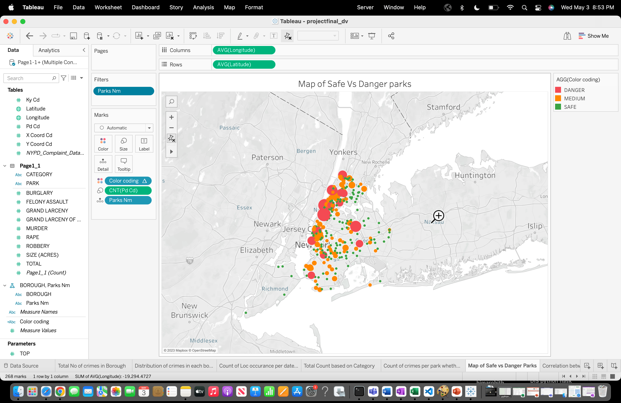

Through the visualization, we can effortlessly identify the safety levels of parks, distinguishing between safe and dangerous ones. In order to facilitate this analysis, a calculated field was introduced by employing the formula:

Colour coding = IF RANK(COUNT([Pd Cd])) < 10 THEN "DANGER"

ELSEIF RANK(COUNT([Pd Cd])) > 100 THEN "SAFE"

ELSE "MEDIUM"

END

This calculated field allows us to assign a colour code to each park based on the count of incidents (represented by [Pd Cd]). Parks ranked within the top 10 are labelled as "DANGER," those ranked beyond 100 are classified as "SAFE," while parks falling between these ranges are labelled as "MEDIUM." This approach aids in quickly assessing the safety level of each park based on the provided data.

**Q7. Correlation of Park Area and Crime Rate using scatter plot?**

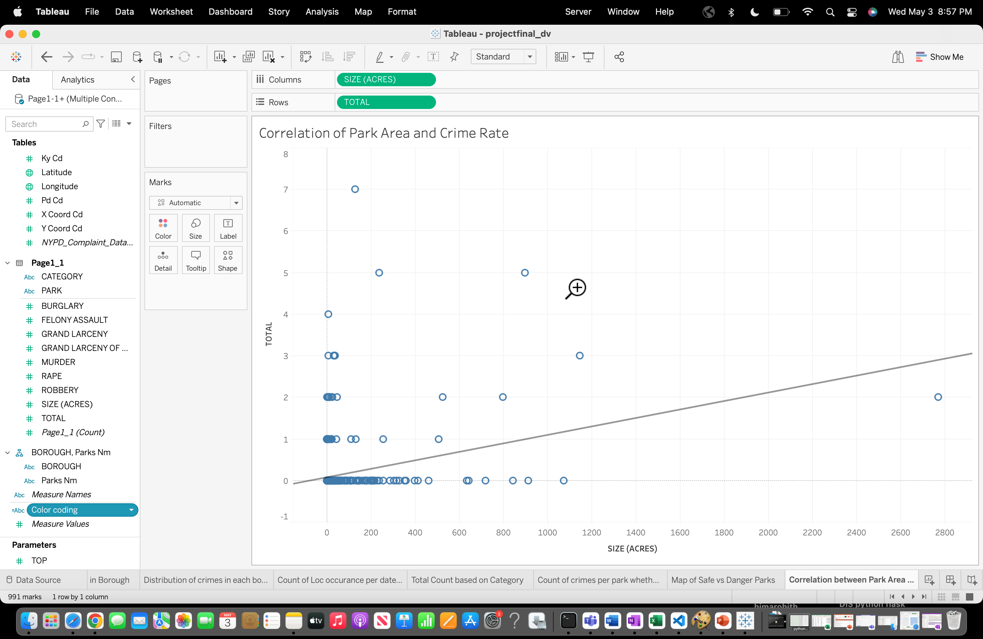

By utilizing a scatter plot with a trend line, we can observe the correlation between park size and the total number of crimes. Notably, the data reveals a trend indicating that parks with smaller areas tend to have lower crime rates. As park size decreases, there is a visible trend of diminishing crime rates.

**Q8. Creating Dashboards to show visualizations?**

**Dashboard-1**

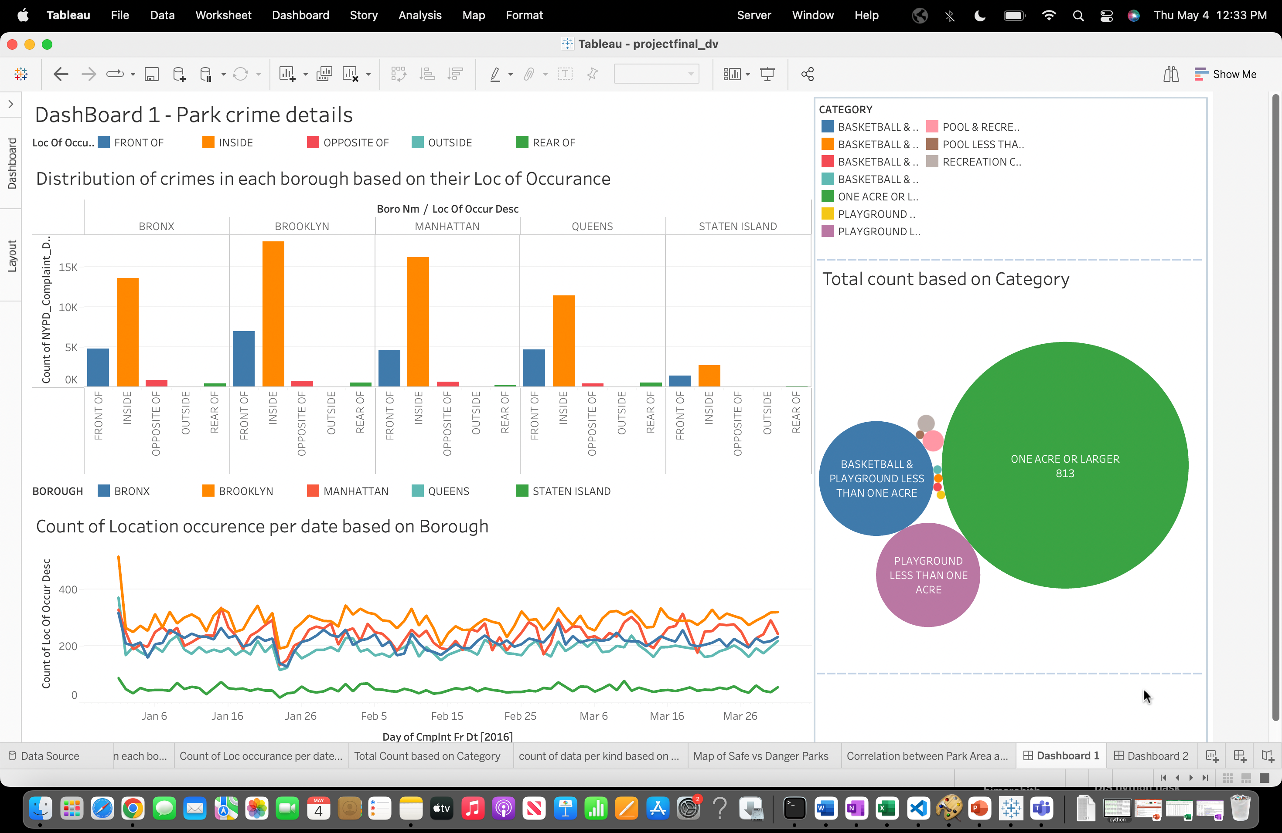

**Dashboard-2**

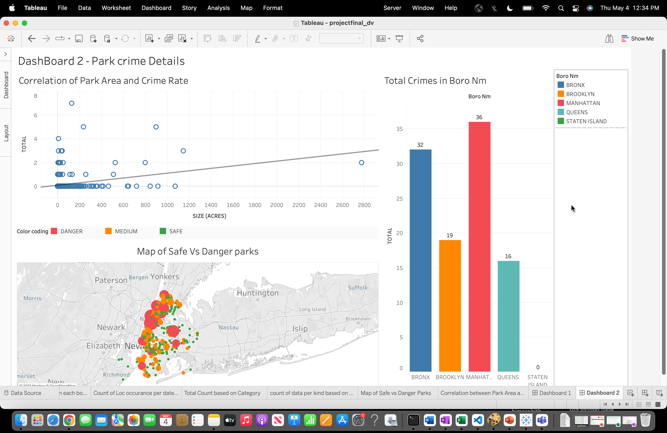

The inclusive dashboards offers a comprehensive perspective on crime distribution, temporal patterns, park safety, and comparative analysis across various boroughs.

By providing maps that identify safe parks, it empowers users to delve into crime patterns, make informed decisions, and devise strategies to bolster public safety in the city, ultimately enabling a more thorough understanding of crime dynamics

# **Conclusion:**

To summarize, the project shed light on the complicated relationship between urban parks and criminal activity in New York City. We've noticed certain types of criminal behaviour that are more likely to occur in or near parks, as well as specific sites within parks when such activity is more frequent.

These findings have profound implications for local government officials and legislators in charge of park leadership and protection. The poll results will help them make choices, enabling them to prioritize safety measures and establish rules that promote a safe park environment.

Furthermore, this research adds to the existing academic literature on the complex connection between urban parks and crime in urban environments.

**Further Research Questions:-**

1. How does the presence or absence of security measures in the parks affect crime rates? Can we create a chart or graph to compare crime rates in parks with and without security measures?
2. Can we create a bubble chart to compare the crime rates in the most dangerous parks with other relevant factors such as park amenities, population density, or proximity to high-crime neighbourhoods?
3. Can we create an interactive dashboard that allows users to explore the crime data in the most dangerous parks by filtering based on date, crime type, or park location?